# Brands Colors:

Color influences our moods and feelings in ways we may not even notice. It shapes our attitudes toward products and brands and is an important differentiator in an increasingly visual world.

Needless to say, color is a powerful marketing tool.

On the most basic level, color can be divided into two categories: warm and cool. Warm color represents energy and passion, while cool colors signify security and calmness.

Google, Microsoft and eBay are three prominent examples of companies that use a rainbow of colors in their logo. From a branding perspective, this signals a lack of focus.

# 1-Brown:

The color brown is a strong color which is closely associated with earthiness, honesty, and dependability. Brown is used very less as a brand color and if it is used, it is mostly used in the food industry.

The below was the most common brand colors in the market and their application for individual brands. In general, each brand color is specific to an industry and Blue and Red are one of the most commonly used brand colors. You can then come up with a color combination to rival the brand. But now you know what those colors stand for.

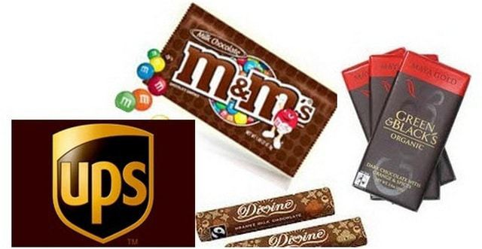

# 2-Red:

In nature, red represents danger. Red evokes an immediate response and activates our senses and raises our heart rate. It communicates passion, aggression, energy, urgency and impulsiveness. Companies in the food and beverage, hospitality, communications and automotive industries typically flock to red. The fast food industry loves red, probably because it commands attention and appeals to our impulsive nature, encouraging our subconscious to give into those cravings.

Since decades gone by, we have used the red color to depict our love or even hatred for something. When a person gets angry, he turns red. When a person loves someone, he shares a red rose. The color red does not stand individually for love or hate. It stands for passion and being passionate.

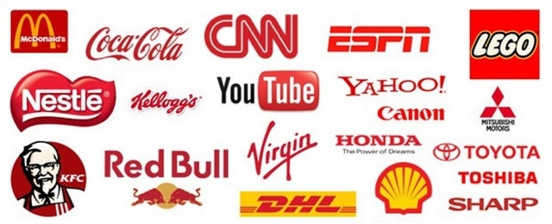

# 3-Yellow:

Yellow reminds us of the sun, and communicates happiness, hope and warmth. It can be used to effectively capture our attention, without feeling as intense as red. It’s commonly used within the food and beverage, home goods and energy industries. Generally, brands that use yellow want to be perceived as friendly and positive. Case in point: McDonald’s. In the early 2000s, their slogan “we love to see you smile” was accompanied by a smile symbol added to their famous golden arches.

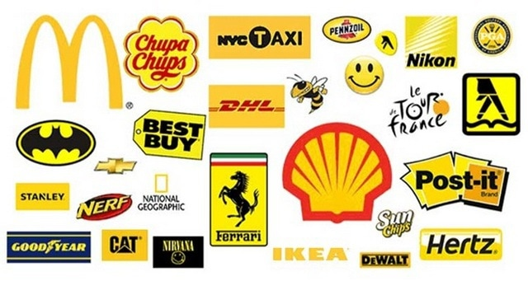

# 4-Green:

Associated with freshness, loyalty, health and wealth, green has been on a steady rise since the start of the new millennium, probably due to our increasing awareness of the environment. Because it reminds us of grass and forests, green makes us feel safe, calm and grounded. The most well-known brand that uses green as its main color is Starbucks. Much of Starbucks’ marketing efforts are targeted toward making the customer feel a sense of loyalty and trust. Starbucks also wants to feel more like a neighborhood coffee joint than a multi-billion dollar brand. However you feel about that, it’s a brand quality that is enhanced by the choice of green.

In essence, the brand color green stands for Cleanliness, freshness and renewed energy.

## 

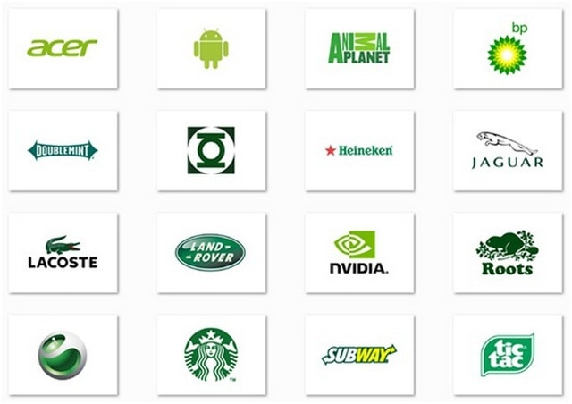

# 5-Pink:

The color pink stands for softness, care, and comfort. Pink is one of the most widely used colors in the cosmetic industry as well as in the personal care industry. Quite recently, the differentiation of the colors viz Pink stands for girls and Blue stands for Boys is being adopted more and more and hence most women-oriented products are generally using pink colors.

However, pink is not a color which has a basis of gender only. Brands like Donut King, and others use the pink color as well.

